HC 2 T1 U1
 | 題目 | 圖片
1 | How old are you?  I’m one. | 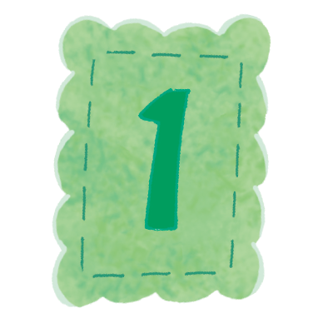
2 | How old are you?  I’m two. | 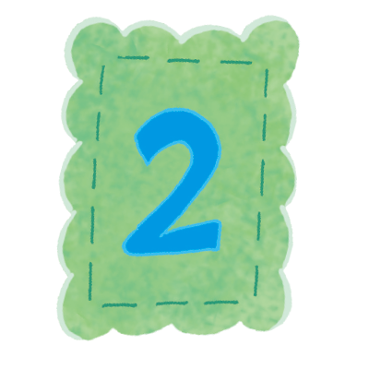
3 | How old are you?  I’m three. | 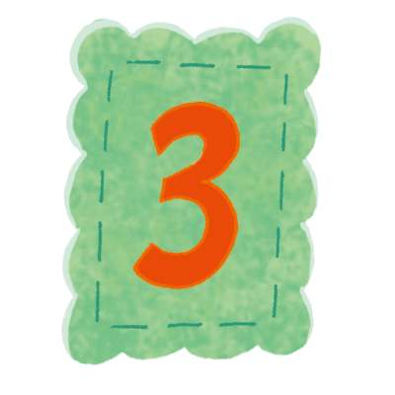
4 | How old are you?  I’m four. | 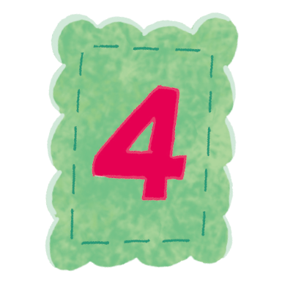
5 | How old are you?  I’m five. | 